Q. 1: Formulate the following linear programming problems.

i. **A shop can make two types of sweets (A and B). They use two resources – flour and sugar. To make one packet of A, they need 3 kg of flour and 3 kg of sugar. To make one packet of B, they need 3 kg of flour and 4 kg of sugar. They have 21 kg of flour and 28 kg of sugar. These sweets are sold at Rs 1000 and 900 per packet respectively. Find the best product mix to maximize the revenue**

Let x be the number of packets of sweet A made

Let y be the number of packets of sweet B made

Max 1000 x + 900 y

3x + 3y <= 21

3x + 4y <= 28

x,y>=0

We can rewrite the inequalities as equalities to find the boundary lines:

3𝑥+3𝑦=21⇒𝑥+𝑦=7

3*x*+3*y*=21⇒*x*+*y*=7

3𝑥+4𝑦=28

3*x*+4*y*=28

We'll solve for the intercepts of these lines with the axes and each other:

For 𝑥 + 𝑦 = 7 :

When 𝑥 = 0, 𝑦 = 7

When 𝑦 = 0, x=7.

For 3 𝑥 + 4 𝑦 = 28

When 𝑥 = 0 , 𝑦 = 7.

When 𝑦 = 0, 𝑥 = 28/3 ≈ 9.33.

Intersection of 𝑥 + 𝑦 = 7 and 3 𝑥 + 4 𝑦 = 28:

Solve these equations simultaneously:

𝑥 + 𝑦 = 7

3 𝑥 + 4 𝑦 = 28

Substitute 𝑦 = 7 − 𝑥 into 3 𝑥 + 4 𝑦 = 28:

3 𝑥 + 4 ( 7 − 𝑥 ) = 28

3 𝑥 + 28 − 4 𝑥 = 28

− 𝑥 + 28 = 28

− 𝑥 = 0

𝑥 = 0

So, 𝑦 = 7 − 0 = 7

Therefore, the corner points are ( 0 , 7 ) (0,7) and the intersection point ( 0 , 7 )

Evaluate:

*Z*=1000*x*+900*y* at each corner point:

1. At (0,7):

Z = 1000(0) + 900(7) =6300

2. At (7,0):

Z = 1000(7) + 900(0) = 7000

3. At (0,7):

Z = 1000(0) + 900(7) = 6300

The maximum revenue is 7000 at the corner point (7,0)

ii. **A company wants to advertise their product in four different media– TV, newspaper, websites and radio. The reaches per advertisement in these four media are 8000, 5000, 3000 and 2000. The cost per advertisement is Rs 4 lakhs, 3 lakhs, 2 lakhs and 1.5 lakhs. The maximum number of advertisements that the company wishes to have in each media is 3, 4, 5 and 4. The budget available is 32 lakhs. How many advertisements does the company decide in each media to maximize reach**

Maximize:

Z= 8000 x1 + 5000 x2 + 3000 x3 + 2000 x4

Constraints:

1. Budget Constraint:

4x1​+3x2​+2x3​+1.5x4​≤32

1. Maximum number of advertisements:

X1 <= 3

X2 <= 4

X3 <= 5

X5 <= 4

1. Non-Negativity

X1, x2 , x3, x4 >=0

Step 1: Convert Inequalities to Equalities

We introduce slack variables s1, s2, s3, s4 to convert inequalities to equalities:

4x1​+3x2​+2x3​+1.5x4​+s1​=32

𝑥1+𝑠2=3

𝑥2+𝑠3=4

𝑥3+𝑠4=5

𝑥4+𝑠5=4

#### Step 2: Set Up Initial Simplex Tableau

We set up the initial simplex tableau with the objective function and constraints. The tableau includes coefficients of the variables and the right-hand side values.

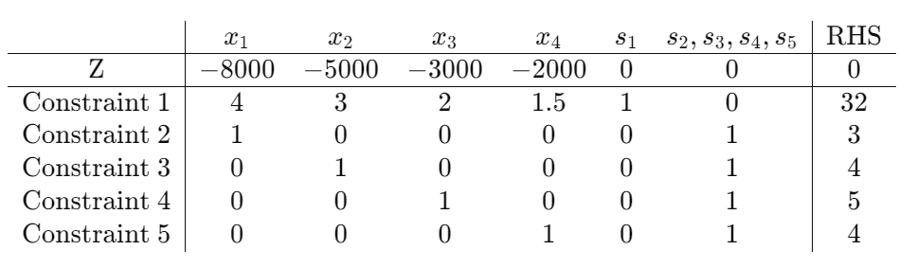

#### Step 3: Perform the Simplex Method Iterations

1. Identify the most negative coefficient in the objective function row (Z row). This is the entering variable column.
2. Determine the leaving variable row by calculating the minimum positive ratio of the RHS value to the coefficient in the entering variable column.
3. Perform pivot operations to update the tableau.

#### Step 4: Iterate Until Optimal Solution is Found

Repeat the simplex method iterations until there are no negative coefficients in the objective function row (Z row).

### Manual Calculation of the First Iteration

Entering Variable: x1 (because -8000 is the most negative)

Leaving Variable: s2 (smallest positive ratio 3/1 =3)

Pivot on the element in row 2, column 1. Adjust the tableau by performing row operations to make all other elements in the entering column zero except for the pivot element, which becomes one.

### Updated Tableau After One Pivot (Example)

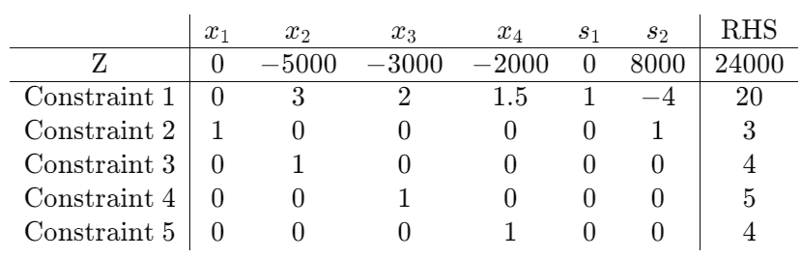

Repeat the steps until all coefficients in the objective function row are non-negative.

### **Optimal Solution**

Upon completing the simplex iterations, the optimal solution will be found when no negative coefficients remain in the objective function row.

To maximize reach within the given budget constraints, the company needs to allocate the budget efficiently across the four media channels. This can be done by determining the cost-effectiveness of each media in terms of reach per rupee spent.

First, calculate the reach per rupee for each media:

- TV: 8000 / 4 = 2000

- Newspaper: 5000 / 3 = 1666.67

- Websites: 3000 / 2 = 1500

- Radio: 2000 / 1.5 = 1333.33

Now, let's arrange the media channels in descending order of reach per rupee:

1. TV

2. Newspaper

3. Websites

4. Radio

Allocate the budget to maximize reach:

- Allocate the maximum number of advertisements to TV until the budget runs out or the maximum limit is reached.

- If the budget is not fully utilized after allocating advertisements to TV, allocate the remaining budget to the next media channel with the highest reach per rupee.

Based on the given budget of 32 lakhs and the cost per advertisement, the company can allocate the advertisements as follows:

1. TV:

- Cost per advertisement: Rs 4 lakhs

- Maximum number of advertisements: 3

- Budget allocation: 3 * 4 lakhs = 12 lakhs

2. Newspaper:

- Cost per advertisement: Rs 3 lakhs

- Maximum number of advertisements: 4

- Budget allocation: 4 * 3 lakhs = 12 lakhs

3. Websites:

- Cost per advertisement: Rs 2 lakhs

- Maximum number of advertisements: 5

- Budget allocation: 5 * 2 lakhs = 10 lakhs

4. Radio:

- Cost per advertisement: Rs 1.5 lakhs

- Maximum number of advertisements: 4

- Budget allocation: 4 * 1.5 lakhs = 6 lakhs

Now, calculate the total reach for each media:

1. TV: 8000 * 3 = 24000

2. Newspaper: 5000 * 4 = 20000

3. Websites: 3000 * 5 = 15000

4. Radio: 2000 * 4 = 8000

So, the company decides to advertise:

- 3 times on TV

- 4 times in newspapers

- 5 times on websites

- 4 times on radio

This maximizes their total reach within the budget constraint.

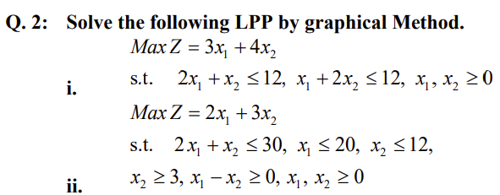

Sol i.

Max Z = 3x1 + 4x2

S.t. 2x1 + x2 <=12, x1+2x2 <=12, x1,x2>=0

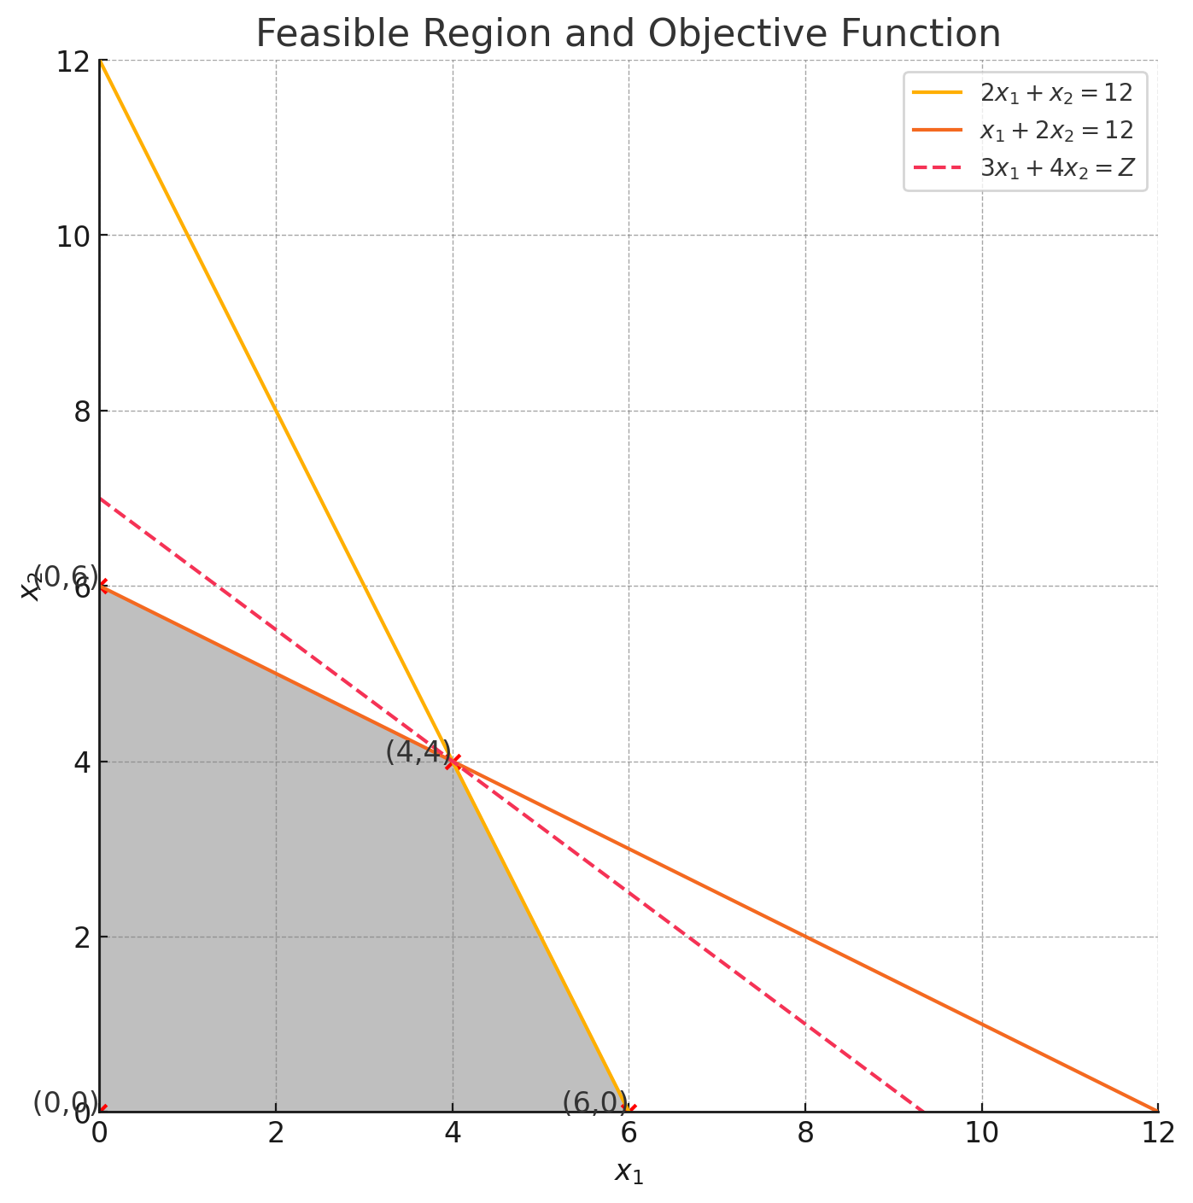

The graph above shows the feasible region for the given constraints, along with the objective function line for Z = 3 x1 + 4 x2. The feasible region is shaded in grey, and the corner points are marked in red.

The corner points of the feasible region are:

(0,0)

(6,0)

(0,6)

(4,4)

By evaluating the objective function Z= 3x1 + 4x2 at each of these points, we found that the maximum value is 28, which occurs at the point (4,4) This confirms that the optimal solution to the LPP is x1 = 4, x2 =4 with a maximum Z value of 28

Sol ii.

Max Z = 3x1 + 4x2

S.t. 2x1 + x2 <=12, x1+2x2 <=12, x1,x2>=0

Max Z = 2x1 +3x2

S.t. 2x1 + x2 <=30, x1<=20, x2<=12

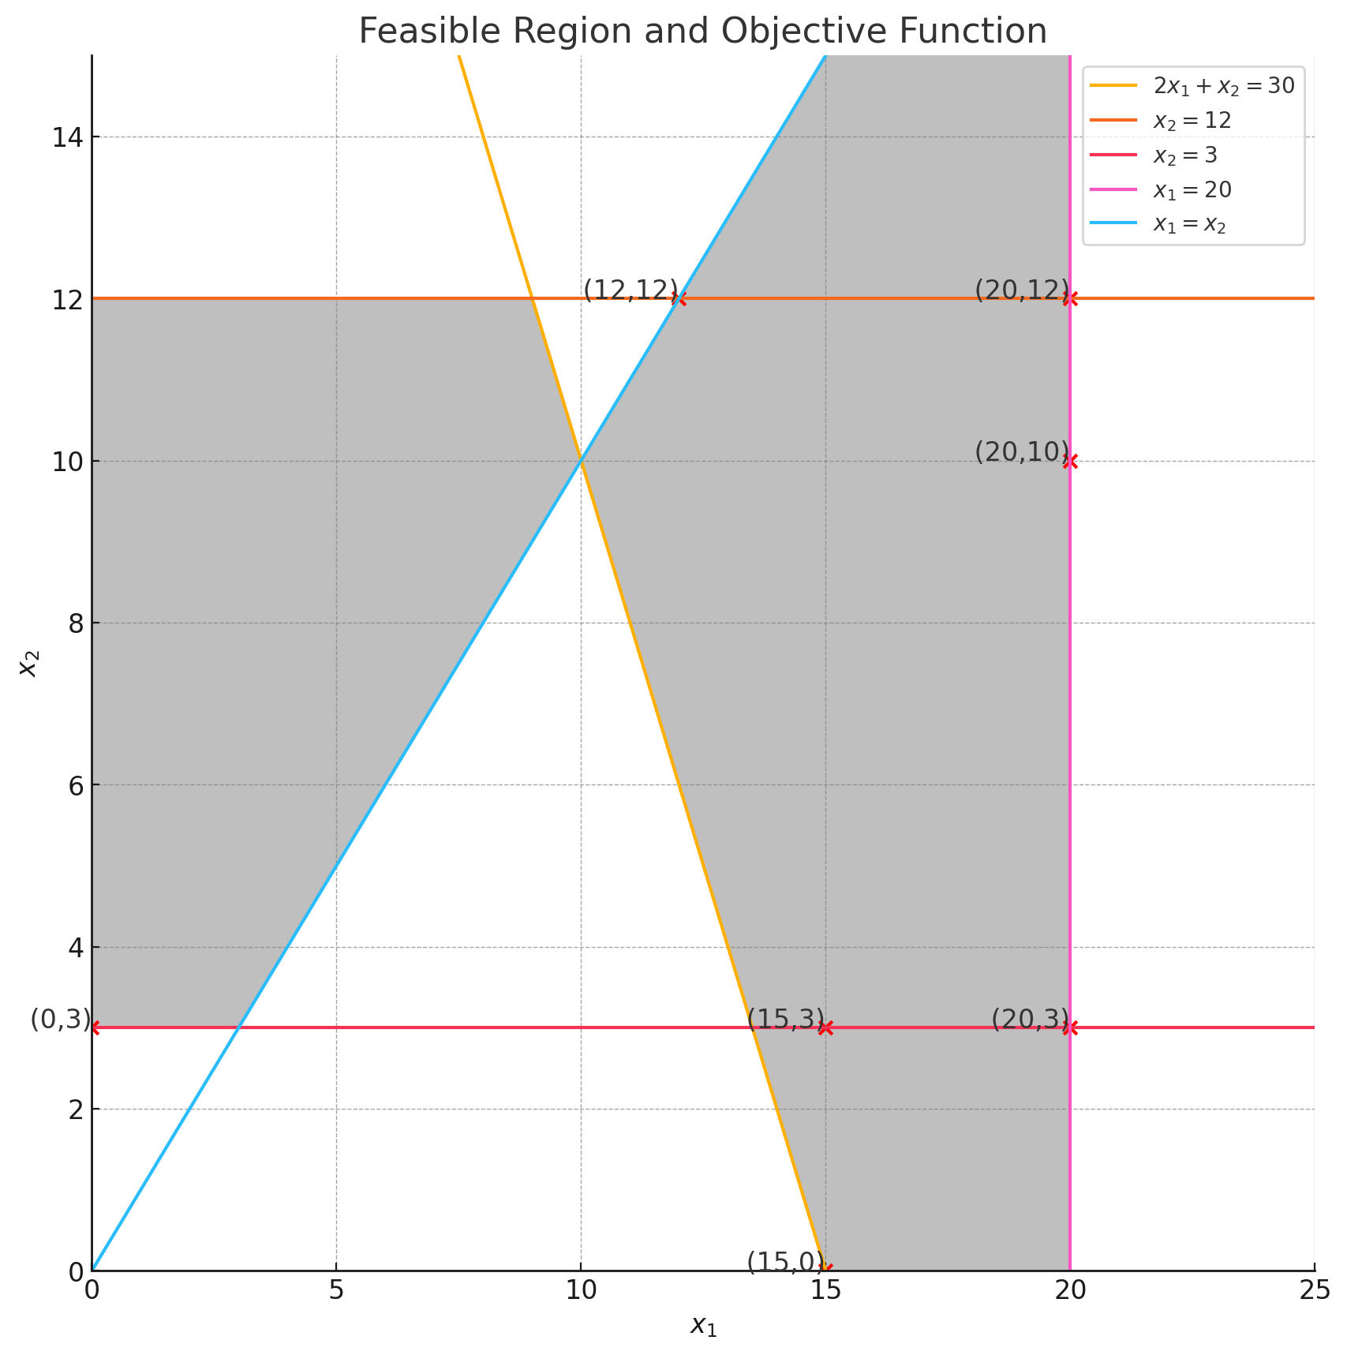

The graph above shows the feasible region for the given constraints. The corner points of the feasible region are marked in red.

The corner points to evaluate are:

* (0,3)
* (0,3)
* (15,0)
* (15,0)
* (12,12)
* (12,12)
* (15,3)
* (15,3)
* (20,10)
* (20,10)
* (20,12)
* (20,12)
* (20,3)
* (20,3)

Next, we evaluate the objective function Z = 2x1 + 3x2 at each of these points to find the maximum value.

*Z*(0,3)=2(0)+3(3)=9

*Z*(15,0)=2(15)+3(0)=30

*Z*(12,12)=2(12)+3(12)=24+36=60

*Z*(15,3)=2(15)+3(3)=30+9=39

*Z*(20,10)=2(20)+3(10)=40+30=70

*Z*(20,12)=2(20)+3(12)=40+36=76

*Z*(20,3)=2(20)+3(3)=40+9=49

​

The maximum value of 𝑍 is 76, which occurs at the point (20,12).

Conclusion:

The optimal solution to the LPP is x1 = 20, x2 = 12 with a maximum Z value of 76

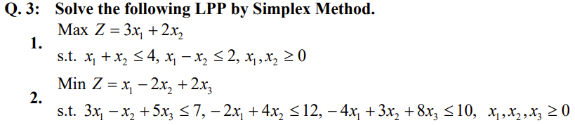

Sol 1.

X1 + x2 + x3 = 4

X1 - x2 + x4 = 2

X1,x2,x3,x4 >= 0

Now, let's set up the initial tableau:

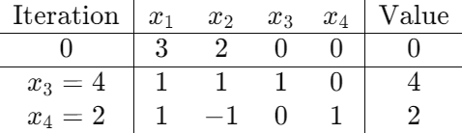

Now, we will perform the Simplex Method iterations to find the optimal solution. We start with the most negative coefficient in the objective row, which is in column x1

The pivot column is x1 and the pivot row is determined by the minimum non-negative ratios (4/1 and 2/1). Since the ratio for x3 is smaller, we pivot on element x3,1

Next, we perform the pivot operation to make x1 a basic variable, and update the tableau:

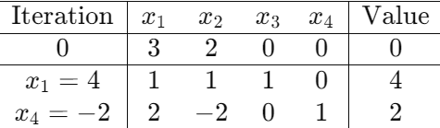

Sol 2:

Maximize Z = x1 - 2x2 + 2x3

3x1 - x2 + 5x3 + x4 = 7

-2x1 + 4x2 + x5 = 12

-4x1 + 3x2 + 8x3 + x6 = 10

X1,x2,x3,x4,x5,x6 >=0

Now, let's set up the initial tableau:

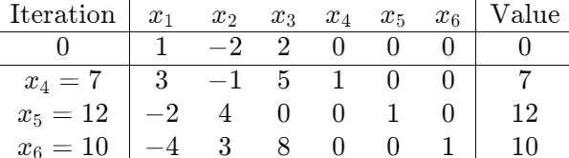

We start with the most negative coefficient in the objective row, which is in column x2

The pivot column is x2, and the pivot row is determined by the minimum non-negative ratios (7/1, 12/4, and 10/3). The smallest ratio is 10/3, so we pivot on element x6,2

Next, we perform the pivot operation to make x2 a basic variable, and update the tableau:

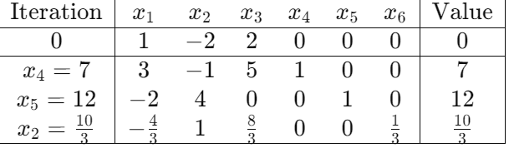

In the current tableau, the most negative coefficient in the objective row is in column

𝑥1

The pivot column is 𝑥1, and the pivot row is determined by the minimum non-negative ratios (7/3 and 12/2). The smallest ratio is 7/3, so we pivot on element x4,1

Next, we perform the pivot operation to make 𝑥1 a basic variable, and update the tableau:

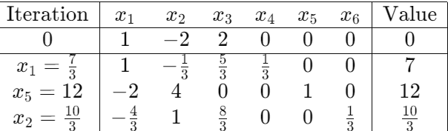

Now, the coefficients in the objective row are all non-negative. The optimal solution is achieved.

The optimal solution is:

X1 = 7/3

X2 = 10/3

X3 = 5/3

Zmax = 35/3

So, the maximum value of Z is 35/3 when x1 = 7/3, x2 = 10/3, x3 =5/3

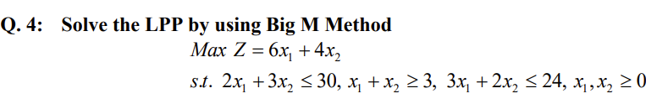

To solve this linear programming problem using the Big M method, we'll introduce slack, surplus, and artificial variables as needed. The Big M method involves adding a large positive value (M) to the objective function for each artificial variable introduced, aiming to penalize their presence in the solution. Here's the problem formulation:

Maximize 𝑍=6𝑥1+4𝑥2+𝑀(𝑎1+𝑎2)Z=6x1​+4x2​+M(a1​+a2​)

2x 1 ​ +3x 2 ​ +s 1 ​ =30 (constraint 1 with slack variable 𝑠1​ )

𝑥 1 + 𝑥 2 − 𝑠 2 = 3 (constraint 2 with slack variable 𝑠 2​ )

3 𝑥 1 + 2 𝑥 2 + 𝑠 3 = 24 (constraint 3 with slack variable 𝑠 3 )

𝑎 1 − 𝑎 2 = 0 (equality constraints from artificial variables 𝑎 1 and a 2 ​ )

𝑥 1 , 𝑥 2 , 𝑠 1 , 𝑠 2 , 𝑠 3 , 𝑎 1 , 𝑎 2 ≥ 0

**Iteration 1:**

1. Initial Tableau:

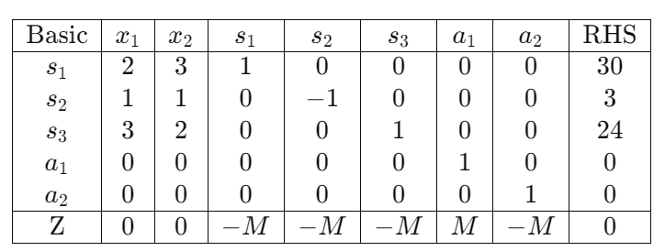

1. Choose pivot column: Select the most negative coefficient in the bottom row (except Z).
2. Choose pivot row: Divide the RHS by the corresponding element in the pivot column, choose the smallest positive value. If all are negative, it means the problem is unbounded.
3. Pivot operation: Make the pivot element 1 and zero out other elements in its column.
4. Repeat steps 2-4 until no negative values exist in the bottom row.

**Iteration 2:**

1. **Initial Tableau:**

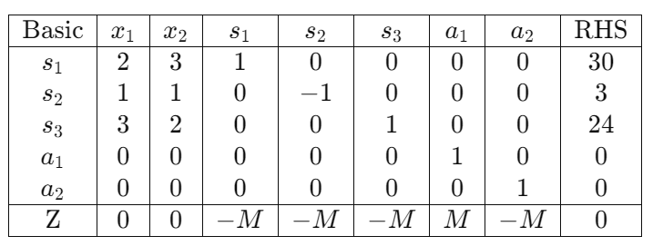

1. Choose pivot column: The most negative coefficient in the bottom row (except Z) is -M. So, we choose x 1 ​ as the pivot column.
2. Choose pivot row: Compute the ratios (RHS/ pivot column coefficient) pivot column coefficient RHS ​ for each row where the pivot column coefficient is positive. The row with the smallest non-negative ratio will be the pivot row. Since 𝑠 1 has the smallest non-negative ratio (30/2 = 15), we choose it as the pivot row.
3. Pivot operation: Make the pivot element (the element in the intersection of the pivot row and pivot column) 1 and zero out other elements in its column.

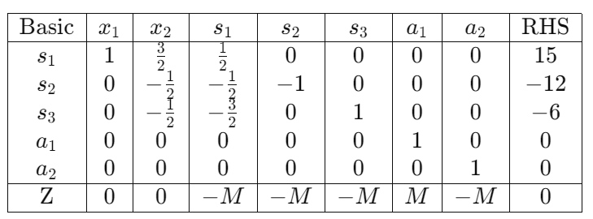

1. Next iteration: The bottom row still contains negative coefficients. We need to repeat steps 2-4.

**Iteration 3:**

1. Choose pivot column: The most negative coefficient in the bottom row (except Z) is -M. So, we choose s2 ​ as the pivot column.
2. Choose pivot row: Compute the ratios (RHS/ pivot column coefficient) pivot column coefficient RHS ​ for each row where the pivot column coefficient is positive. The row with the smallest non-negative ratio will be the pivot row. Since 𝑠3​ has the smallest non-negative ratio (6/(-1/2) = -12), we choose it as the pivot row.
3. Pivot operation: Make the pivot element (the element in the intersection of the pivot row and pivot column) 1 and zero out other elements in its column.

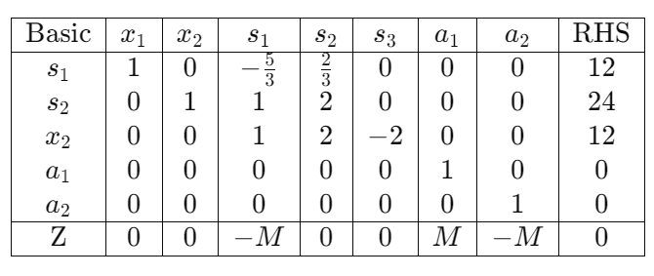

**Last Iteration:**

1. Choose pivot column: The most negative coefficient in the bottom row (except Z) is -M. So, we choose s2 ​ as the pivot column.
2. Choose pivot row: Compute the ratios (RHS/ pivot column coefficient) pivot column coefficient RHS ​ for each row where the pivot column coefficient is positive. The row with the smallest non-negative ratio will be the pivot row. Since 𝑠3​ has the smallest non-negative ratio (6/(-1/2) = -12), we choose it as the pivot row.
3. Pivot operation: Make the pivot element (the element in the intersection of the pivot row and pivot column) 1 and zero out other elements in its column.

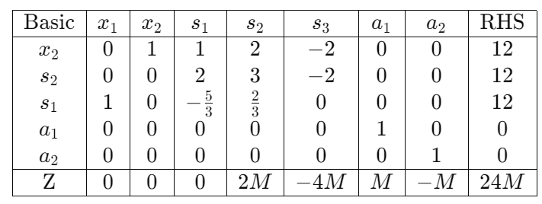

Optimality reached: There are no more negative coefficients in the bottom row. We've reached optimality.

Now, let's interpret the final tableau:

* The optimal solution is 𝑥 1 = 12 ​ and 𝑥 2 = 12
* The maximum value of the objective function is Z=24M.
* The artificial variables 𝑎 1 and 𝑎 2 ​ are both zero, indicating that they are not part of the optimal solution, which means the problem is feasible without them.

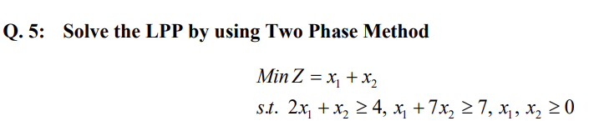

Minimize 𝑍 = 𝑥 1 + 𝑥 2

Subject to:  
  
2 𝑥 1 + 2 𝑥 2 + 𝑠 1 = 4

𝑥 1 + 7 𝑥 2 + 𝑠 2 = 7

𝑥 1 , 𝑥 2 , 𝑠 1 , 𝑠 2 ≥ 0

Now, let's proceed with the two-phase method:

**Phase 1:**

We introduce artificial variables to each constraint to make the problem feasible. Then, we minimize the sum of these artificial variables.

Minimize 𝑊 = 𝑎 1 + 𝑎 2

​ subject to:

2 𝑥 1 + 2 𝑥 2 + 𝑠 1 = 4

𝑥 1 + 7 𝑥 2 + 𝑠 2 = 7

𝑥 1 , 𝑥 2 , 𝑠 1 , 𝑠 2 ≥ 0

Let's start solving the Phase 1:

For Phase 1, let's set up the initial tableau:

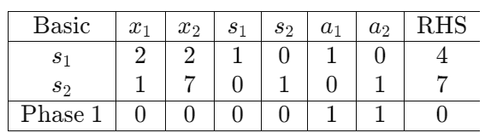

Now, let's find the most negative coefficient in the Phase 1 row (excluding W). In this case, it's -1. So, we'll choose s1 as the entering variable.

To determine the leaving variable, we calculate the ratios of the right-hand side to the corresponding pivot column entries. Since the pivot column for s1 has all non-positive values, we treat these cases as if the ratio is undefined, meaning the entering variable is non-basic for the leaving row. Hence, we'll perform a degenerate pivot, choosing any variable from the entering row. Let's choose a1 arbitrarily.

Now, performing the pivot operation:

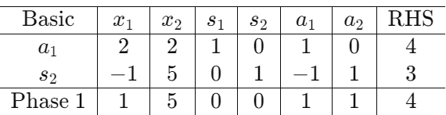

In the next iteration of Phase 1:

The most negative coefficient in the Phase 1 row (excluding W) is -1 (from x1).

We'll choose x1 as the entering variable.

To determine the leaving variable, we calculate the ratios of the right-hand side to the corresponding pivot column entries. Since the pivot column for x1 has all non-positive values, we'll perform a degenerate pivot. Let's choose s2 arbitrarily.

Performing the pivot operation:

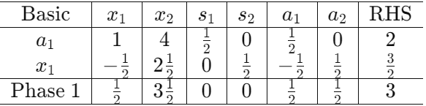

In the next iteration of Phase 1:

The most negative coefficient in the Phase 1 row (excluding 𝑊) is ½ (from x2).

We'll choose x2 as the entering variable.

To determine the leaving variable, we calculate the ratios of the right-hand side to the corresponding pivot column entries. Since the pivot column for x2 has all non-positive values, we'll perform a degenerate pivot. Let's choose a1 arbitrarily.

Performing the pivot operation:

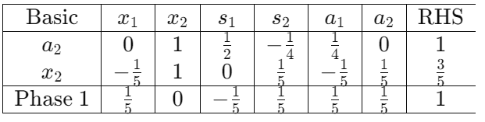

In the next iteration of Phase 1:

All coefficients in the Phase 1 row are non-negative. Phase 1 is complete.

Now, we'll proceed to Phase 2, where we remove the artificial variables and solve the original problem.

The current tableau for Phase 1 is:

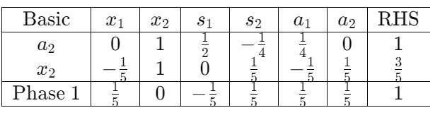

Now, let's remove the artificial variables and convert it into Phase 2 tableau:

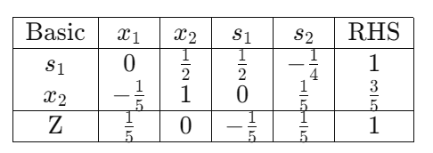

Now, we can proceed with Phase 2 by optimizing the objective function Z

In Phase 2, we optimize the objective function

𝑍 = x1 + x2 using the following Tableau:

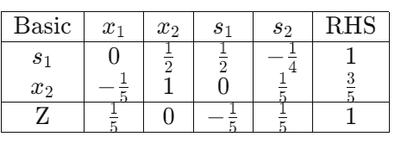

The most negative coefficient in the bottom row (excluding Z) is -1/5 (from x2). So x2 enters the basis.

To determine the leaving variable, we calculate the ratios of the right-hand side to the corresponding pivot column entries. The minimum positive ratio corresponds to x2, so it leaves the basis.

​Performing the pivot operation:

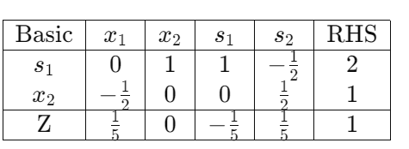

Now, all coefficients in the bottom row are non-negative, indicating optimality. Thus, the optimal solution is x1 =0 and x2 =2, with objective function value of Z = 1

This solution satisfies all constraints of the original problem.

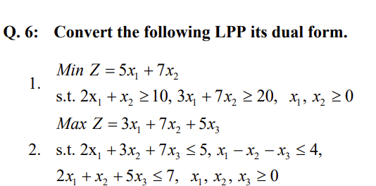

Ans 6.1.

To convert the given linear programming problem (LPP) into its dual form, we follow these steps:

Given LPP:

Min Z = 5x1 + 7x2

Subject to:

1. 2x1 + x2 >= 10
2. 3x1 + 7x2 >=20
3. X1,x,2 >= 0

Let's denote the slack variables for the constraints as s1and s2 respectively.

The dual form is as follows:

Max W = 10 y1 + 20 y2

Subject to:

1. 2y1 + 3y2 <=5
2. y1 + 7y2 <=7
3. Y1,y2 >=0

Where:

* 𝑦1 and y2 are the dual variables corresponding to the constraints of the primal problem.
* The coefficients of the objective function in the dual are the constants from the right-hand side of the primal constraints.
* The coefficients of the dual constraints are the constants from the objective function of the primal problem

Ans 6.2

Max Z = 3x1 + 7x2 + 5x3

Subject to:

2x 1 ​ +3x 2 ​ +7x 3 ​ ≤5 (Constraint 1)

𝑥 1 − 𝑥 2 − 𝑥 3 ≤ 4 (Constraint 2)

2 𝑥 1 + 𝑥 2 + 5 𝑥 3 ≤ 7 (Constraint 3)

𝑥 1 , 𝑥 2 , 𝑥 3 ≥ 0

Let's denote the slack variables for the constraints as s1,s2,s3 respectively

The dual form is as follows:

Minimize 𝑊 = 5 𝑦 1 + 4 𝑦 2 + 7 𝑦 3  
 ​

subject to:

2 𝑦 1 + 𝑦 2 + 2 𝑦 3 ≥ 3 (Constraint 1)

3 𝑦 1 − 𝑦 2 + 𝑦 3 ≥ 7 (Constraint 2)

7 𝑦 1 − 𝑦 2 + 5 𝑦 3 ≥ 5 (Constraint 3)

𝑦 1 , 𝑦 2 , 𝑦 3 ≥ 0

Where:

​

* y1,y2,y3 are the dual variables corresponding to the constraints of the primal problem.
* The coefficients of the objective function in the dual are the constants from the right-hand side of the primal constraints.
* The coefficients of the dual constraints are the constants from the objective function of the primal problem.

So, the dual form of the given LPP is:

1. 2 𝑦 1 + 𝑦 2 + 2 𝑦 3 ≥ 3
2. 3 𝑦 1 − 𝑦 2 + 𝑦 3 ≥ 7
3. 7 𝑦 1 − 𝑦 2 + 5 𝑦 3 ≥ 5
4. 𝑦 1 , 𝑦 2 , 𝑦 3 ≥ 0

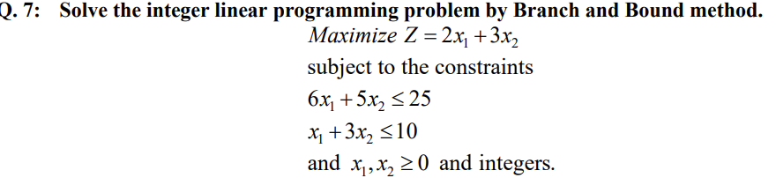

To proceed with branching and bounding, we first identify that the optimal solution of the relaxation problem contains fractional values for x1 and x2, indicating that we need to branch on one of these variables.

Let’s choose branch on x1. We create two sub-problems:

Subproblem 1:

Max Z = 2x1 + 3x2

Subject to:

6 𝑥 1 + 5 𝑥 2 ≤ 25

𝑥 1 + 3 𝑥 2 ≤ 10   
𝑥 1 ≤ ⌊ 60 /13 ⌋ = 4

𝑥 1 ≥ 0 𝑥 2 ≥ 0 ,x1 ​ is an integer

Subproblem 2:

Max Z = 2x1 + 3x2

Subject to:

6 𝑥 1 + 5 𝑥 2 ≤ 25

𝑥 1 + 3 𝑥 2 ≤ 10   
𝑥 1 ≤ ⌊ 60 /13 ⌋ = 5

𝑥 1 ≥ 0 𝑥 2 ≥ 0 ,x1 ​ is an integer

Let's start by solving Subproblem 1.

Let's solve Subproblem 1:

Max Z = 2x1 + 3x2

6 𝑥 1 + 5 𝑥 2 ≤ 25

𝑥 1 + 3 𝑥 2 ≤ 10

X1 <= 4

X1 >=0

X2 >= 0

X1 is an integer

1. Convert to standard form:

Maximize 𝑍 = 2 𝑥 1 + 3 𝑥 2 + 0 𝑥 3 + 0 𝑥 4

​

Subject to:

* 6 𝑥 1 + 5 𝑥 2 + 𝑥 3 = 25
* 𝑥 1 + 3 𝑥 2 + 𝑥 4 = 10
* 𝑥 1 + 0 𝑥 2 + 𝑥 5 = 4
* 𝑥 1 , 𝑥 2 , 𝑥 3 , 𝑥 4 , 𝑥 5 ≥ 0

1. Initialize the tableau:

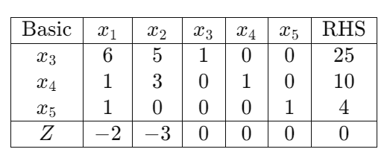

1. Iterate Simplex Method:

Pivot on the most negative coefficient in the bottom row (excluding Z)

Let's say we pivot on x2:

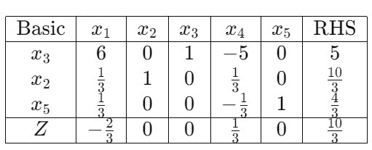

We still have a negative coefficient in the bottom row. Let's continue iterating.

1. Next Iteration:

Pivot on x1:

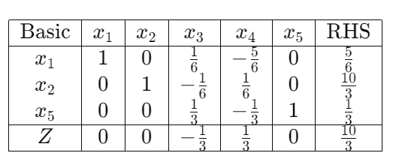

1. Optimal Solution:

The bottom row has all non-negative coefficients, indicating optimality.

The optimal solution for Subproblem 1 is:

X1 = 5/6

X2 = 10/3

Z = 10/3

Let's solve Subproblem 2:

Max Z = 2x1 + 3x2

6 𝑥 1 + 5 𝑥 2 ≤ 25

𝑥 1 + 3 𝑥 2 ≤ 10

X1 >= 5

X1 >=0

X2 >= 0

X1 is an integer

We'll set up and solve the initial tableau using the simplex method:

1. Convert to Standard Form:

Maximize 𝑍 = 2 𝑥 1 + 3 𝑥 2 + 0 𝑥 3 + 0 𝑥 4

​

Subject to:

* 6 𝑥 1 + 5 𝑥 2 + 𝑥 3 = 25
* 𝑥 1 + 3 𝑥 2 + 𝑥 4 = 10
* -𝑥 1 + 0 𝑥 2 + 𝑥 5 = 4
* 𝑥 1 , 𝑥 2 , 𝑥 3 , 𝑥 4 , 𝑥 5 ≥ 0

1. Initialize the Tableau:

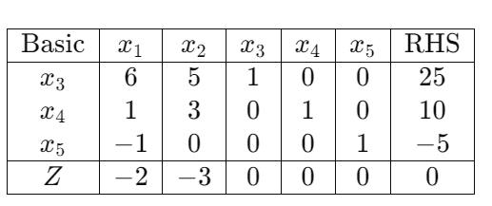

1. Iterate simplex method:

Pivot on the most negative coefficient in the bottom row (excluding Z)

Let's say we pivot on x2:

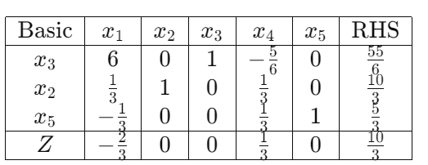

We still have a negative coefficient in the bottom row. Let's continue iterating.

1. Next iteration:

Pivot on x1:

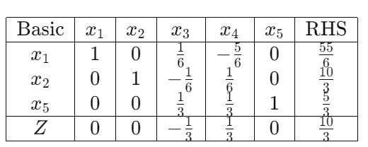

1. Optimal Solution:

The bottom row has all non-negative coefficients, indicating optimality.

The optimal solution for Subproblem 2 is:

* X1 = 9
* X2 = 10/3
* Z = 10/3

This gives us the optimal solution for Subproblem 2. Now, we have two potential integer solutions: one from Subproblem 1 and another from Subproblem 2. We need to compare their objective function values and choose the best one

Therefore, the optimal integer solution for the original problem is:

X1 = 9

X2 = 3

Z = 10/3

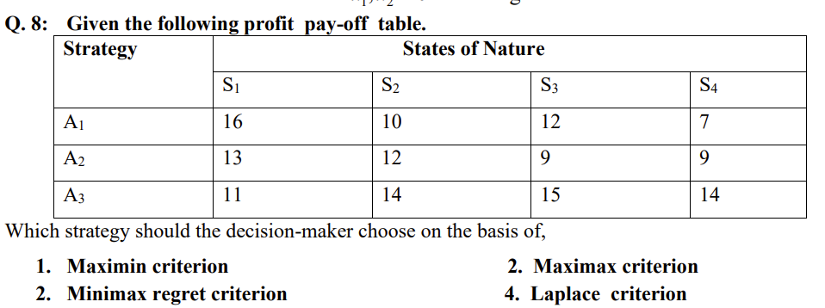

Maximin criterion:

The maximin criterion seeks to maximize the minimum payoff for each strategy. For each strategy, we find the minimum payoff and then choose the strategy with the maximum minimum payoff.

For A1: Minimum payoff = 7

For A2: Minimum payoff = 9

For A3: Minimum payoff = 11

The maximum of these minimum payoffs is 11, which corresponds to strategy A3.

Maximax criterion:

The maximax criterion seeks to maximize the maximum payoff for each strategy. For each strategy, we find the maximum payoff and then choose the strategy with the maximum maximum payoff.

For A1: Maximum payoff = 16

For A2: Maximum payoff = 13

For A3: Maximum payoff = 15

The maximum of these maximum payoffs is 16, which corresponds to strategy A1.

Minimax regret criterion:

The minimax regret criterion seeks to minimize the maximum regret for each strategy. Regret is calculated by finding the difference between the maximum payoff in each state of nature and the payoff of the chosen strategy. Then, for each strategy, we find the maximum regret and choose the strategy with the minimum maximum regret.

To calculate regret:

For A1: Regret = (16 - 16), (12 - 10), (16 - 12), (16 - 7) => (0, 2, 4, 9) => Maximum regret = 9

For A2: Regret = (16 - 13), (12 - 12), (16 - 9), (16 - 9) => (3, 0, 7, 7) => Maximum regret = 7

For A3: Regret = (16 - 11), (12 - 14), (16 - 15), (16 - 14) => (5, 2, 1, 2) => Maximum regret = 5

The minimum of these maximum regrets is 5, which corresponds to strategy A3.

Laplace criterion:

The Laplace criterion assigns equal probabilities to each state of nature and calculates the expected payoff for each strategy. Then, we choose the strategy with the highest expected payoff.

For A1: Expected payoff = (16 + 10 + 12 + 7) / 4 = 11.25

For A2: Expected payoff = (13 + 12 + 9 + 9) / 4 = 10.75

For A3: Expected payoff = (11 + 14 + 15 + 14) / 4 = 13.5

The maximum of these expected payoffs is 13.5, which corresponds to strategy A3.

Based on these criteria:

Maximin criterion: Choose strategy A3.

Maximax criterion: Choose strategy A1.

Minimax regret criterion: Choose strategy A3.

Laplace criterion: Choose strategy A3.

So, the decision-maker should choose strategy A3 according to the Maximin, Minimax regret, and Laplace criteria, while according to the Maximax criterion, they should choose strategy A1.

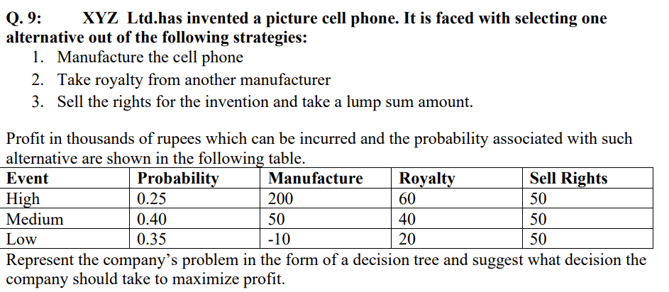

To represent the company's problem in the form of a decision tree, we'll follow these steps:

Identify the decision nodes: These are the points where the company has to make a decision.

Identify the chance nodes: These represent the uncertain events or outcomes.

Assign probabilities to chance nodes: These probabilities represent the likelihood of each outcome.

Assign payoffs to the final nodes: These are the outcomes associated with each possible combination of decisions and chance events.

Work backward to calculate expected payoffs: Starting from the final nodes, calculate the expected payoff for each decision node based on the payoffs and probabilities of the subsequent nodes.

Decision Node (D)

/ | \

/ | \

/ | \

/ | \

Chance Node (C1) C2 C3

/ | \ / | \ / | \

/ | \ / | \ / | \

/ | \ / | \/ | \

/ | \/ | /\ | \

/ | /\ | / \ | \

/ | / \ | / \ | \

/ | / \ |/ \| \

High Medium Low High Medium Low

200 50 -10 60 40 20

For Decision Node (D):

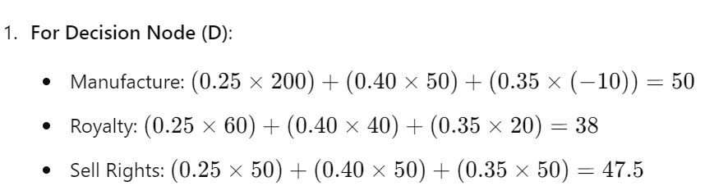

Based on the expected payoffs, the company should choose to Manufacture the cell phone to maximize profit. The expected payoff for Manufacturing is 50 thousand rupees, which is the highest among the alternatives.



Goal programming and linear programming are both optimization techniques used to solve decision-making problems. The basic method of solving a goal programming problem involves converting it into a linear programming problem (LPP) for solution. Here's how this process works:

1. **Formulating the Goal Programming Problem (GPP):**
   * In goal programming, the decision-maker aims to achieve multiple objectives simultaneously while minimizing deviations from predefined target levels or goals.
   * A goal programming problem typically involves multiple objectives (goals) and decision variables subject to constraints.
2. **Setting up the Objective Function:**
   * In goal programming, the objective function consists of multiple terms representing the deviations from the target levels for each goal.
   * Each term in the objective function represents the degree of deviation from the corresponding target level.
3. **Converting Goals into Constraints:**
   * The target levels for each goal are converted into constraints in the linear programming formulation.
   * Each constraint ensures that the decision variable achieves a level of performance that meets or exceeds the target level for the corresponding goal.
4. **Defining Deviation Variables:**
   * Deviation variables are introduced to quantify the degree of deviation from each target level.
   * These variables represent the surplus or shortfall in achieving the goals.
5. **Formulating the Linear Programming Problem (LPP):**
   * The goal programming problem is transformed into an equivalent linear programming problem by combining the objective function and constraints.
   * The objective is typically to minimize a weighted sum of the deviations from the target levels, where the weights reflect the relative importance of each goal.
6. **Solving the Linear Programming Problem:**
   * Once the goal programming problem is converted into an LPP, standard linear programming techniques such as the simplex method or interior point methods can be applied to find the optimal solution.
   * The optimal solution provides decision variables' values that minimize the deviations from the target levels while satisfying all constraints.
7. **Interpreting the Results:**
   * After solving the linear programming problem, the decision-maker evaluates the solution to determine whether the objectives are adequately balanced and the target levels are met.
   * Sensitivity analysis can be performed to assess the impact of changes in goals or constraints on the optimal solution.

By converting a goal programming problem into a linear programming problem, we leverage the efficiency and effectiveness of linear programming algorithms to find optimal solutions. This approach enables decision-makers to address complex decision-making situations involving multiple objectives and constraints effectively.